PETER PHILLIPS
Director

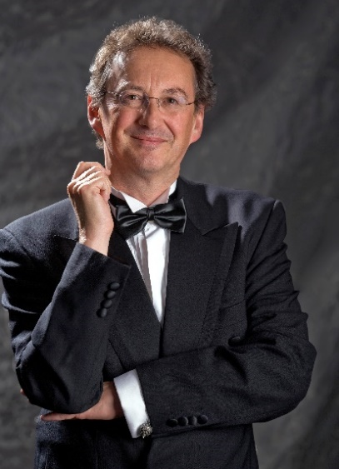
Peter Phillips has dedicated his career to the research and performance of Renaissance polyphony, and to the perfecting of choral sound. Having won a scholarship to Oxford in 1972, he gained experience as an undergraduate in conducting small vocal ensembles, already experimenting with the rarer parts of the repertoire. He founded The Tallis Scholars in 1973, with whom he has now appeared in over 2,300 concerts and made over 60 discs, encouraging interest in polyphony all over the world. As a result of this commitment Peter Phillips and The Tallis Scholars have done more than any other group to establish the sacred vocal music of the Renaissance as one of the great repertoires of Western classical music.
Peter Phillips also conducts other specialist ensembles. He is currently working with the BBC Singers, the Netherlands Chamber Choir, the Estonian Philharmonic Chamber Choir and the Choeur de Chambre de Namur. He is patron of the choirs of Merton College (Oxford), Sansara (London), El Leon de Oro (Spain), and of the Festivals of Portsmouth and Clifton; he also hosts the annual Tallis Scholars Summer Course in Avila (Spain). In 2014 he launched the London International A Cappella Choir Competition in St John's Smith Square, attracting choirs from all over the world.
In addition to conducting, Peter Phillips is well-known as a writer. For 33 years he contributed a regular music column (as well as one, more briefly, on cricket) to The Spectator. In 1995 he became the owner and Publisher of The Musical Times, the oldest continuously published music journal in the world. His first book, English Sacred Music 1549-1649, was published by Gimell in 1991, while his second, What We Really Do, appeared in 2013. During 2018, BBC Radio 3 broadcast his view of Renaissance polyphony, in a series of six hour-long programmes.
In 2005 Peter Phillips was made a Chevalier de l'Ordre des Arts et des Lettres by the French Minister of Culture, a decoration intended to honour individuals who have contributed to the understanding of French culture in the world. In 2008, Peter began an association with Merton College, Oxford, where he helped to found the chapel choir, and where he is a Bodley Fellow.
Photo © Albert Roosenburg

www.thetallisscholars.co.uk / www.gimell.com

This biography is valid for use until July 2021. We update our biographies regularly and ask that they are not altered without permission. For updated versions, please e-mail sm@jamesbrownmanagement.com

